**AWS FreeRTOS INSTALLATION**

**Prerequisites**

**Ensure that the host machine is running Ubuntu 20.4 WSL (Windows subsystem for Linux) on Windows 10.**

### **INSTALLATION OF WSL IN WINDOWS 10**

**To install WSL using Setting on Windows 10, use these steps:**

1. **Open Settings and ‘Click’ on Apps**

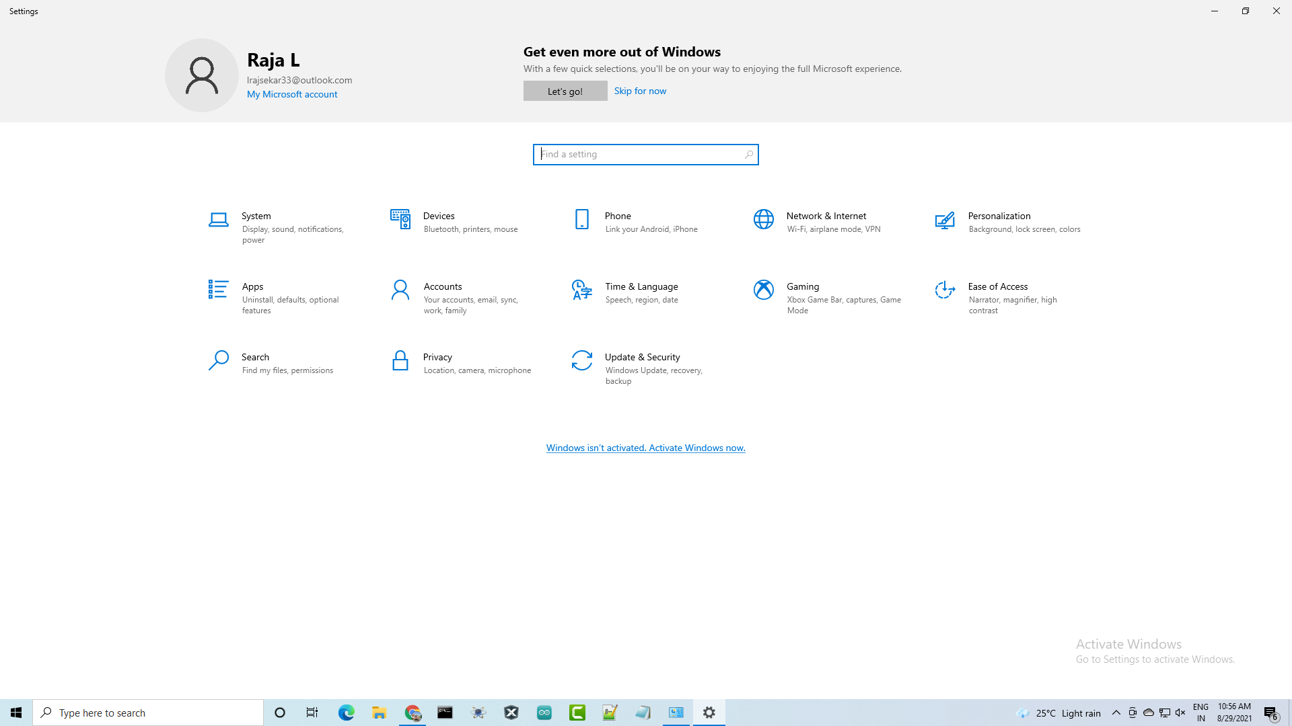

1. **Select the Programs and Features option from the "Related settings" section.**

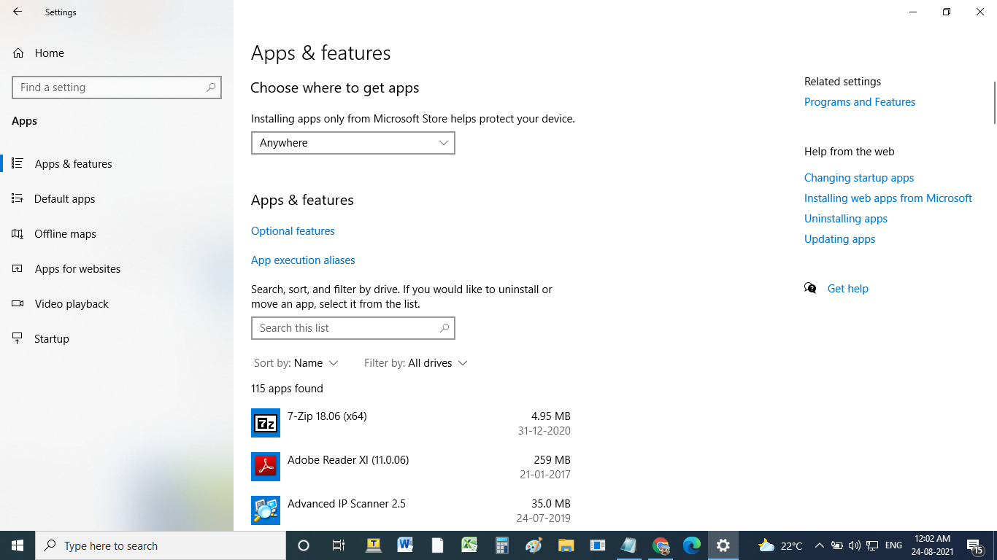

1. **From the left pane, select ‘Turn Windows features on or off.**

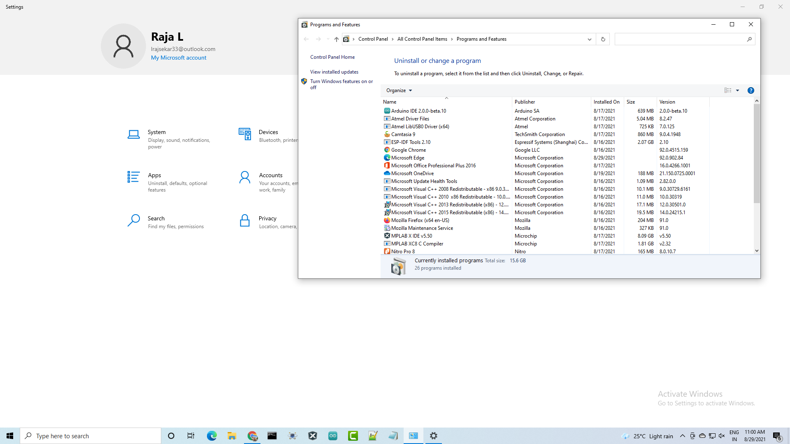

1. **The Windows Subsystem for the Linux option should be checked.**

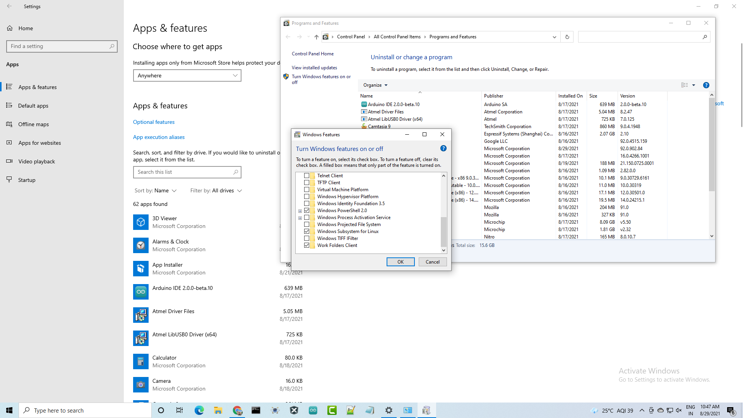

1. **Click the OK button.**
2. **Restart the machine.**
3. **Now, The environment will be configured to download and execute Ubuntu 20.4 WSL on Windows 10 once you finish the instructions.**

**INSTALLING UBUNTU 20.4 WSL USING MICROSOFT STORE**

**Follow these steps to install a Linux distribution on Windows 10:**

1. **Open Microsoft Store.**

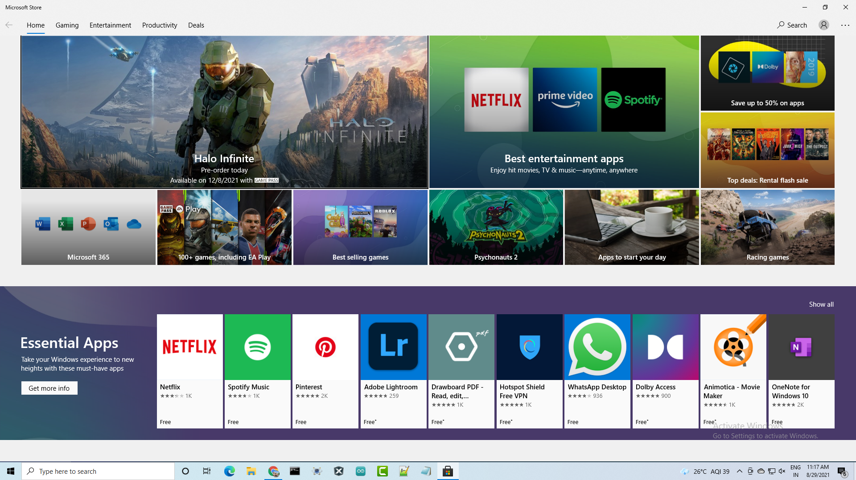

1. **Look for the Ubuntu 20.4 you want to install on your computer.**

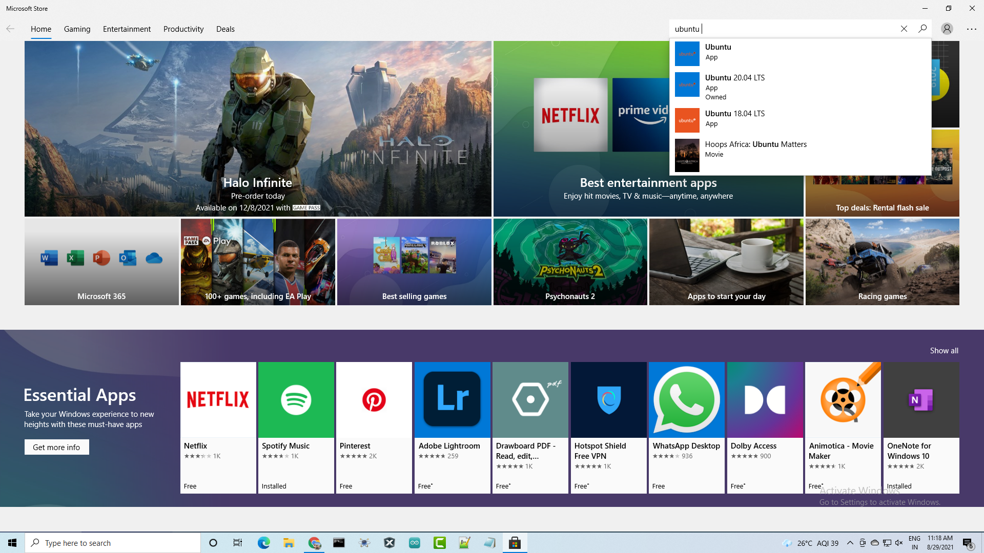

1. **Select Get (or Install) from the option.**

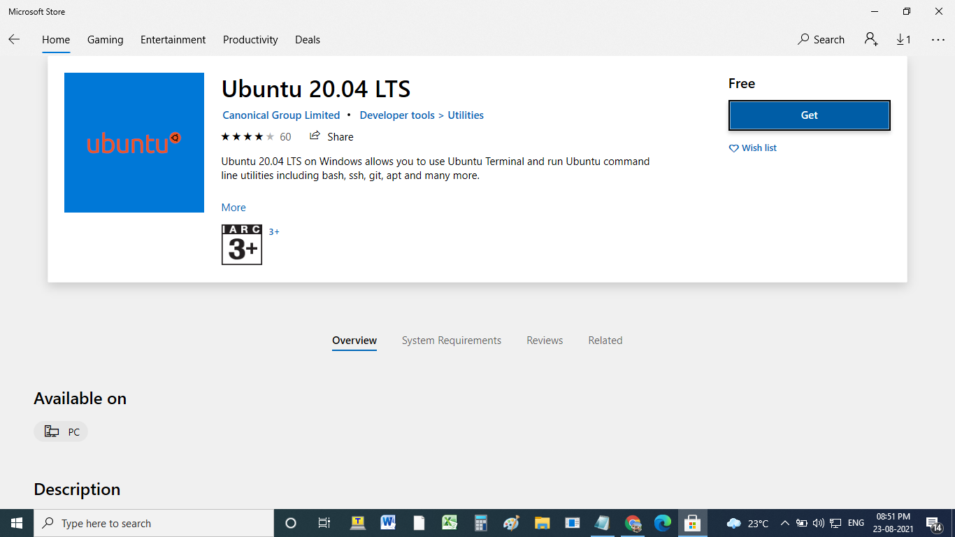

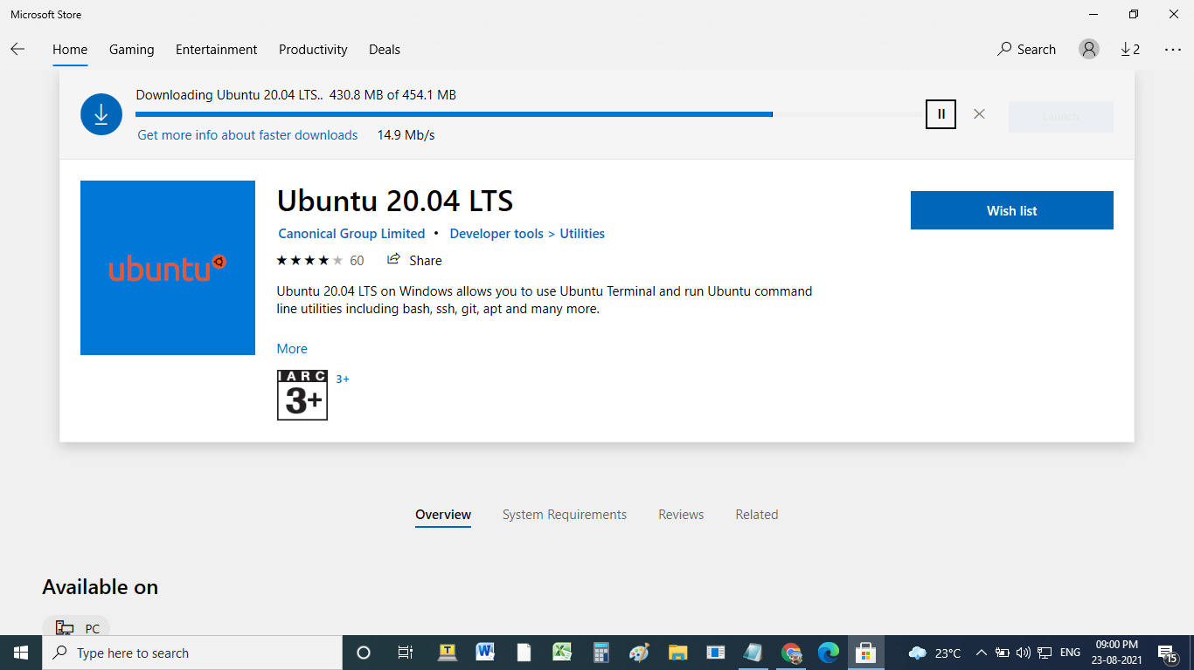

1. **To begin, click the Launch button.**

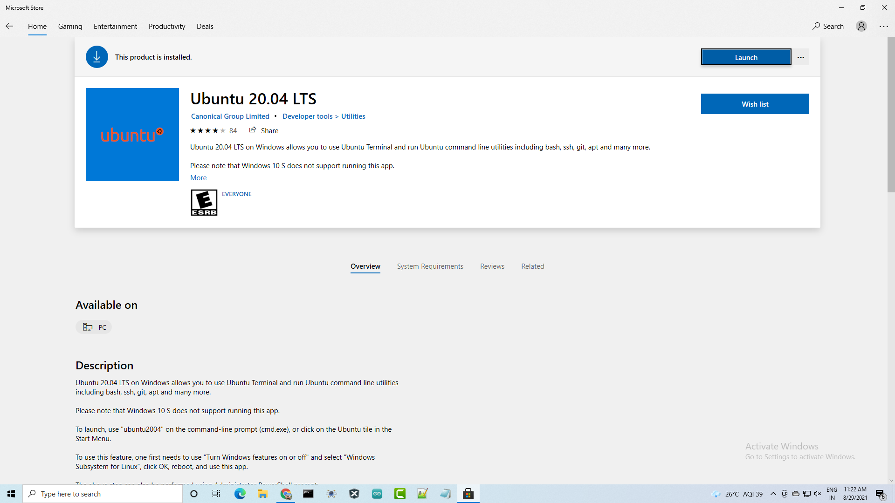

1. **Ubuntu WSL installation takes a few minutes. After that Create a username and password**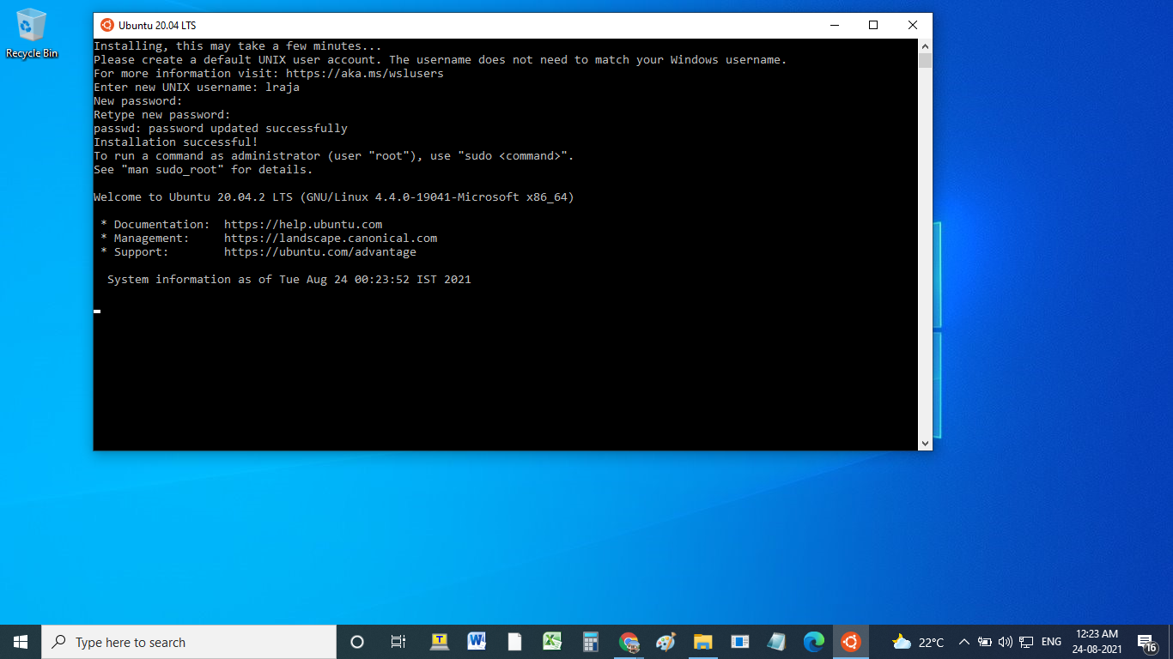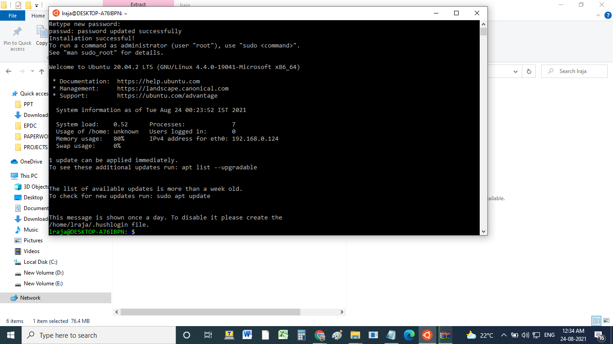
2. **After you've finished the instructions, you'll be able to use the Ubuntu WSL.**

**AWS FreeRTOS INSTALLATION**

1. **Click the link below** [**https://aws.amazon.com/freertos/**](https://aws.amazon.com/freertos/) **.his will bring us to the home page as below**

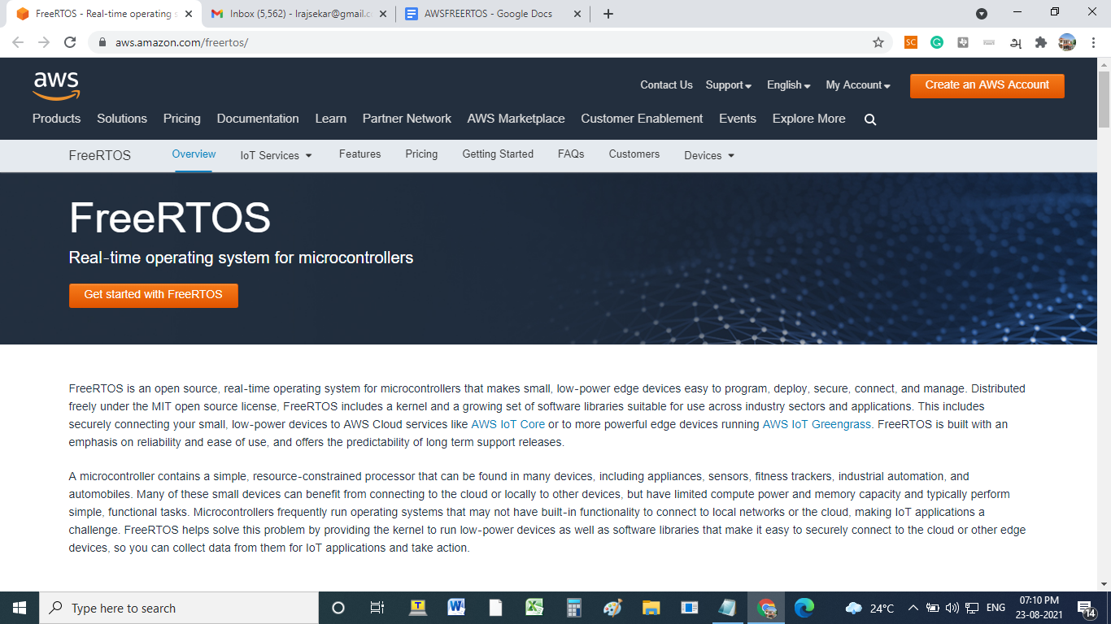

1. **Click started with FreeRTOS. This will bring us to the sign-in page and login with your details(create your AWS login and enter the credential)**

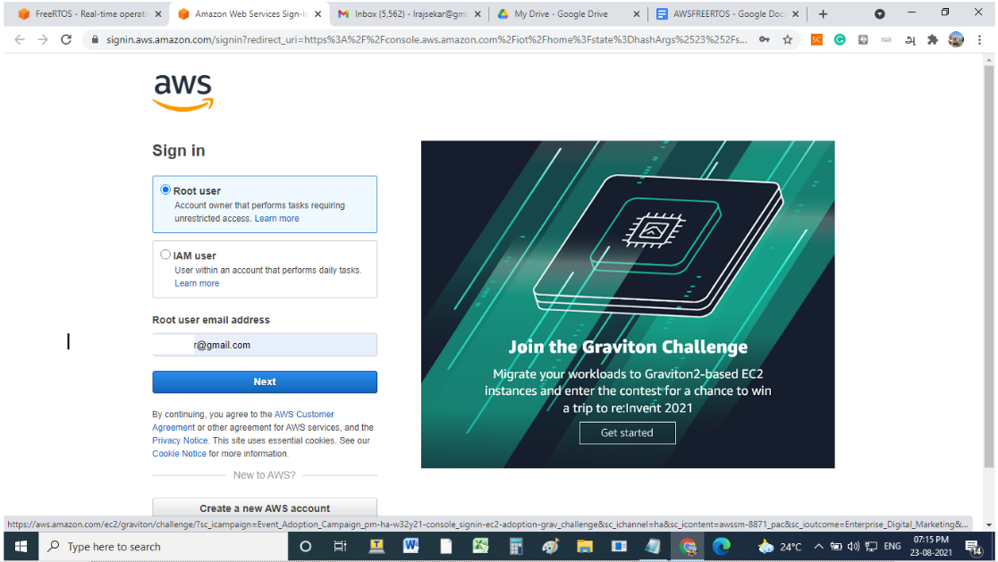

1. **After successful login, this will bring us to the new page as below**

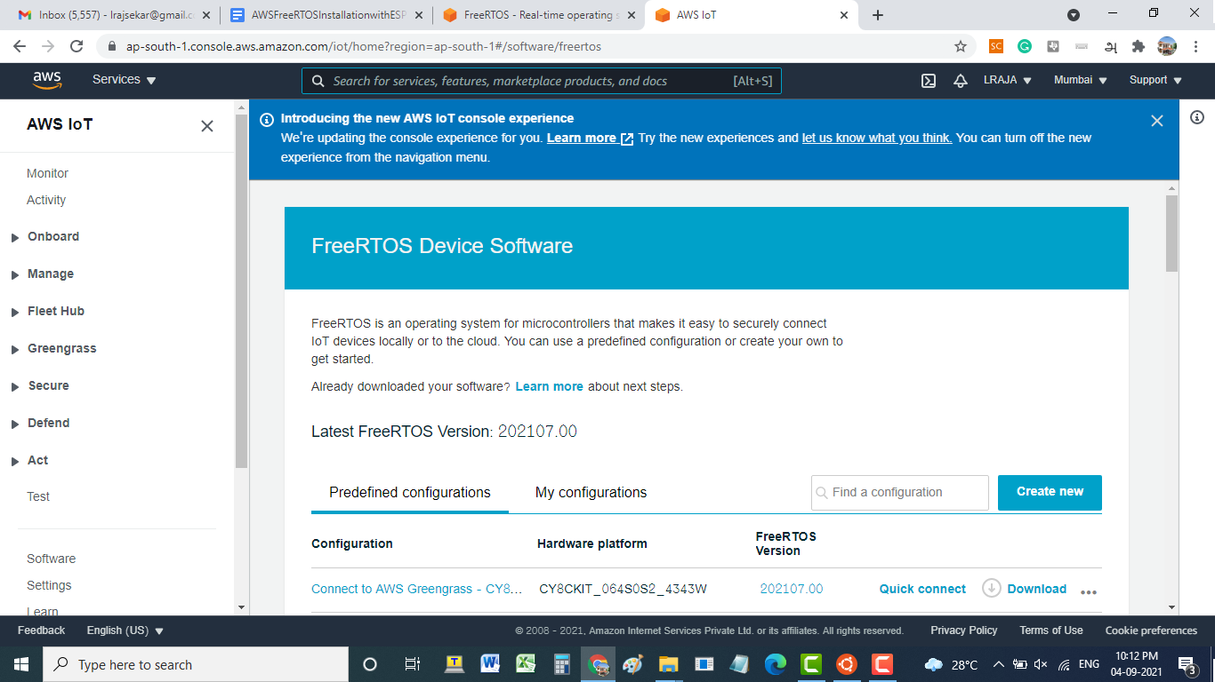

1. **Now select and download suitable FreeRTOS for the microcontroller. Find AWS IoT - ESP32-DevKitC FreeRTOS for ESP32 microcontroller. Click “Quick connect” to configure the microcontroller to work with the AWS cloud and followed by click “get started”.**

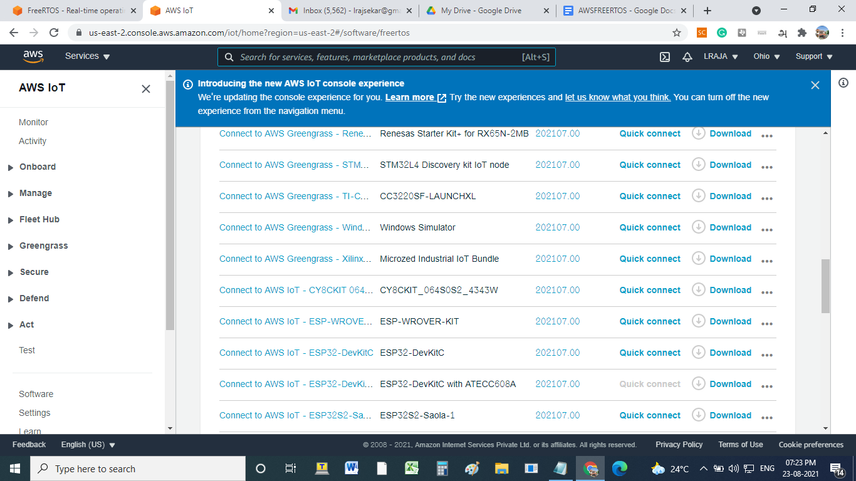

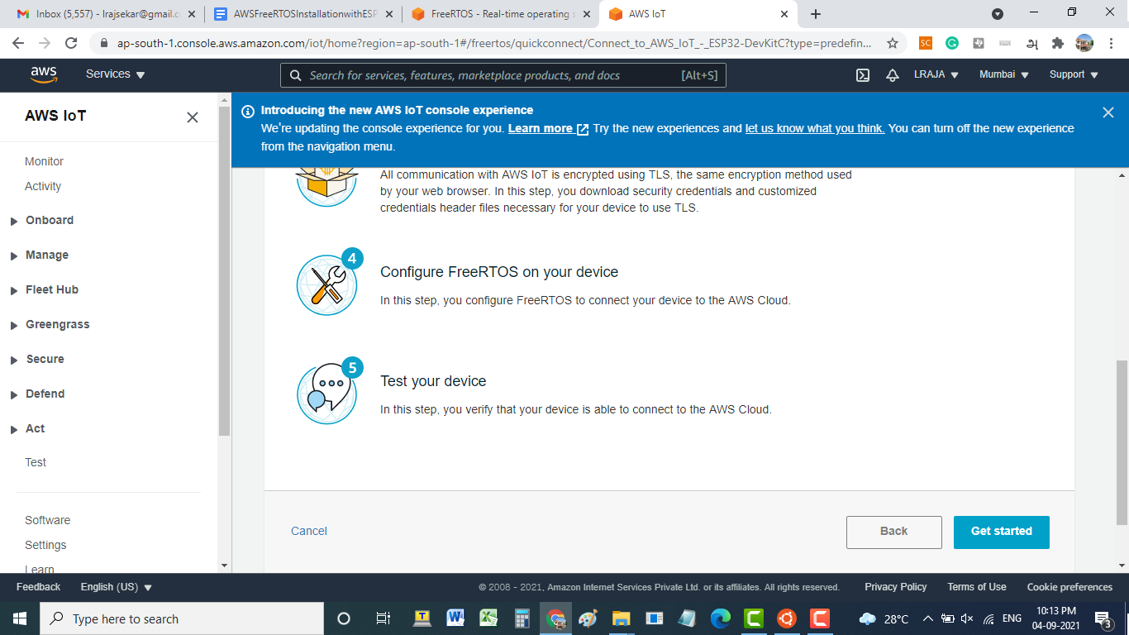

1. **Now Select the Core MQTT demo project that we want to build**

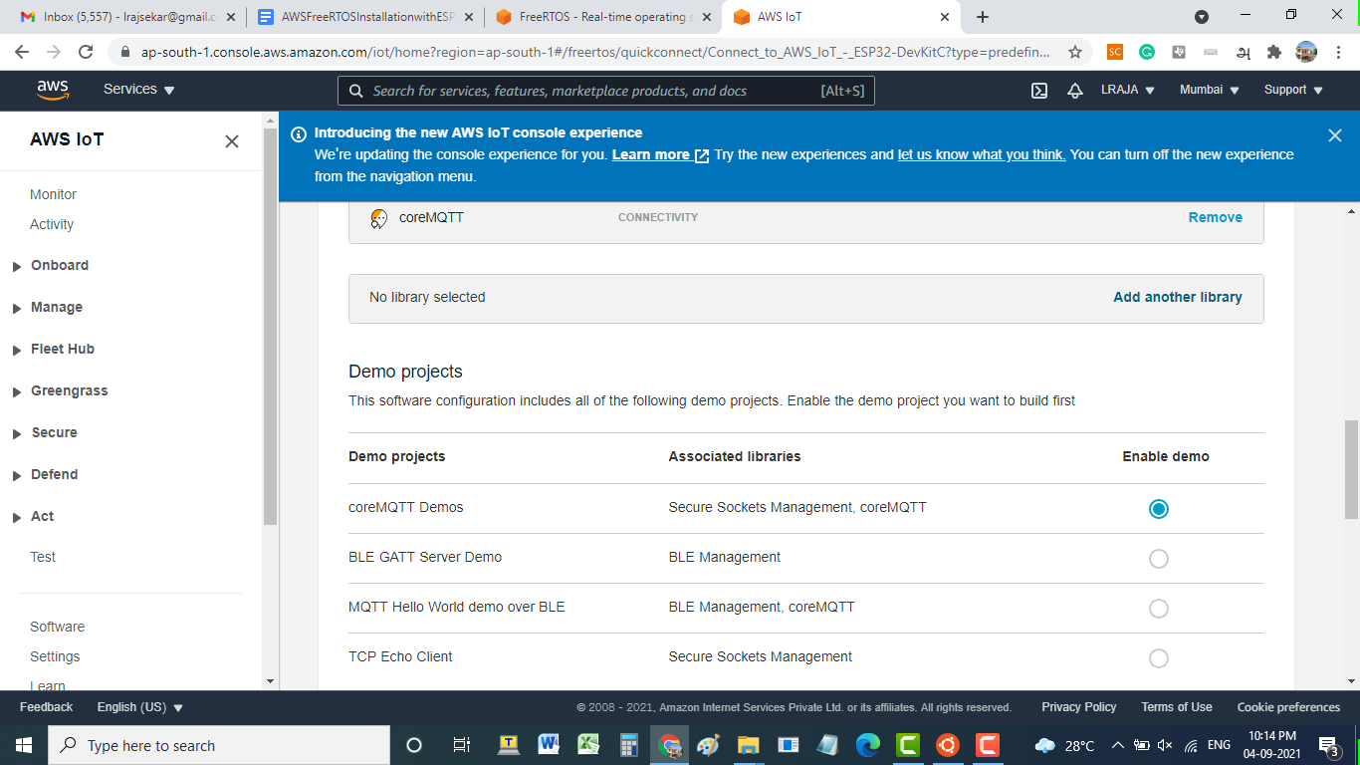

1. **Now Select additional libraries to extend the functionality of the FreeRTOS kernel and click the “add another library” option to add the coreMQTT libraries of your choice.**

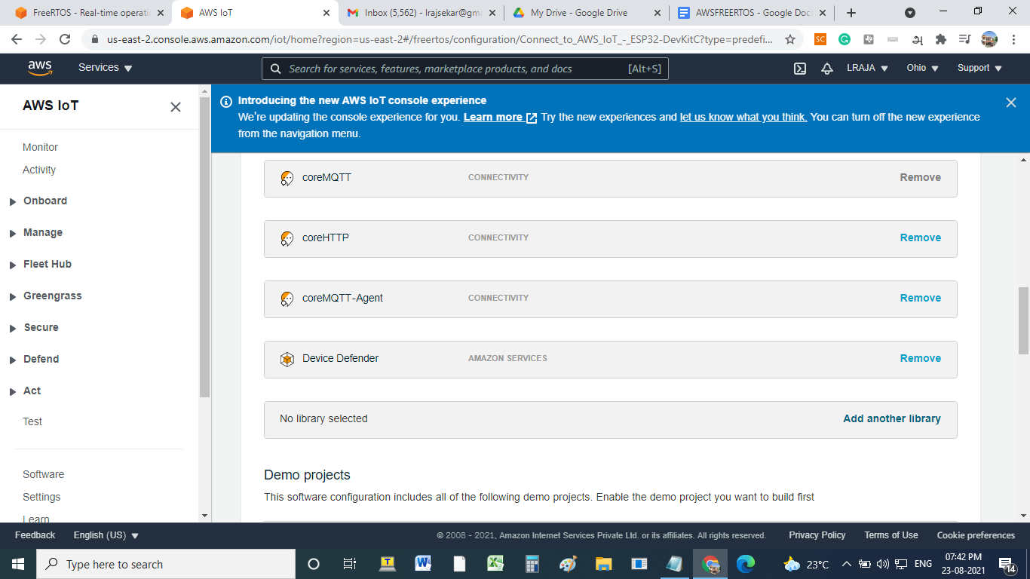

1. **Now click the “create and download” option to download the FreeRTOS**

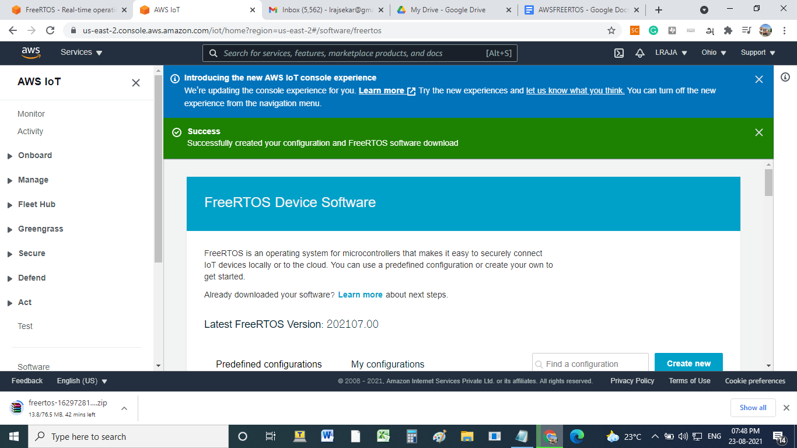

1. **Now Copy the downloaded FreeRTOS file and paste it into**

**\\wsl$\Ubuntu-20.04\home\<user name> folder**

**Ex: \\wsl$\Ubuntu-20.04\home\sam**

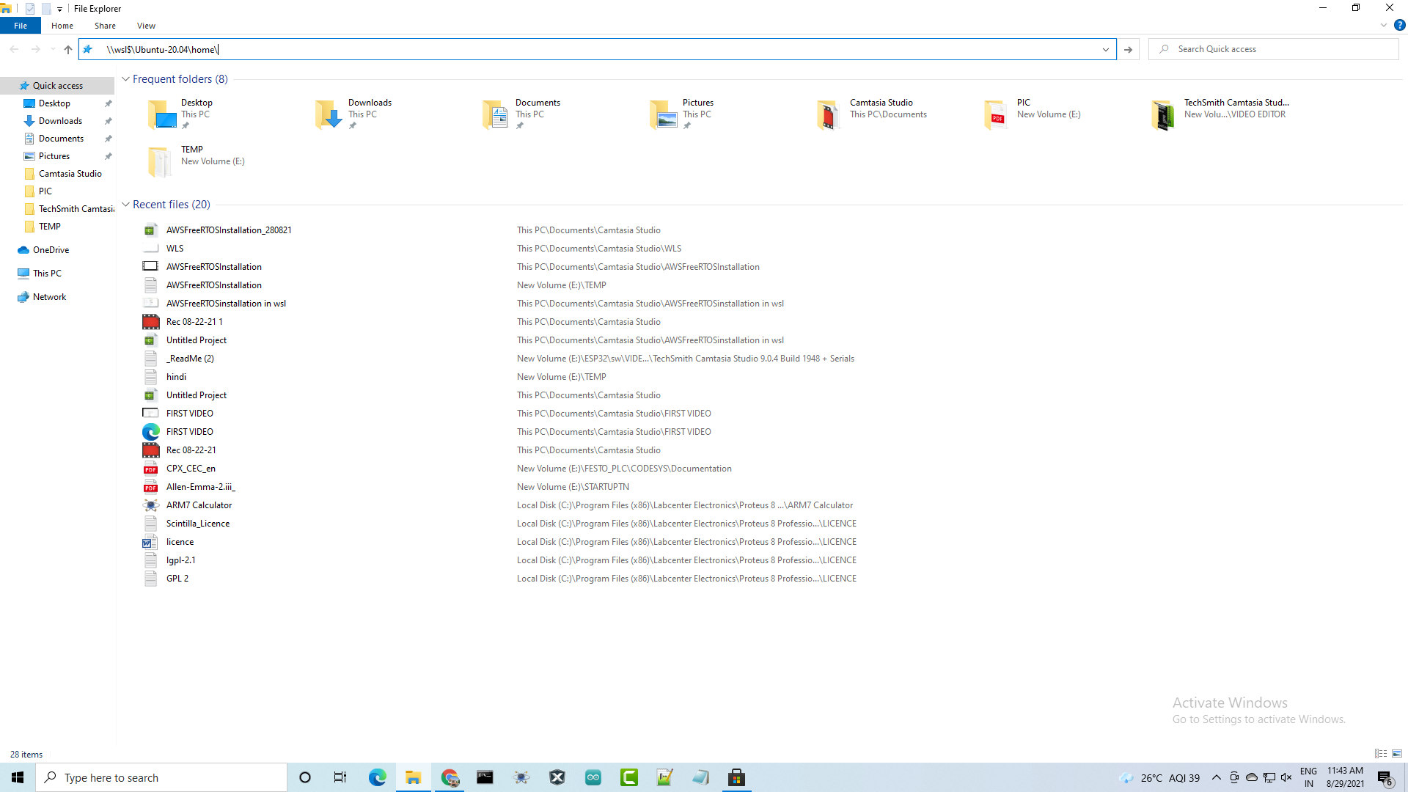

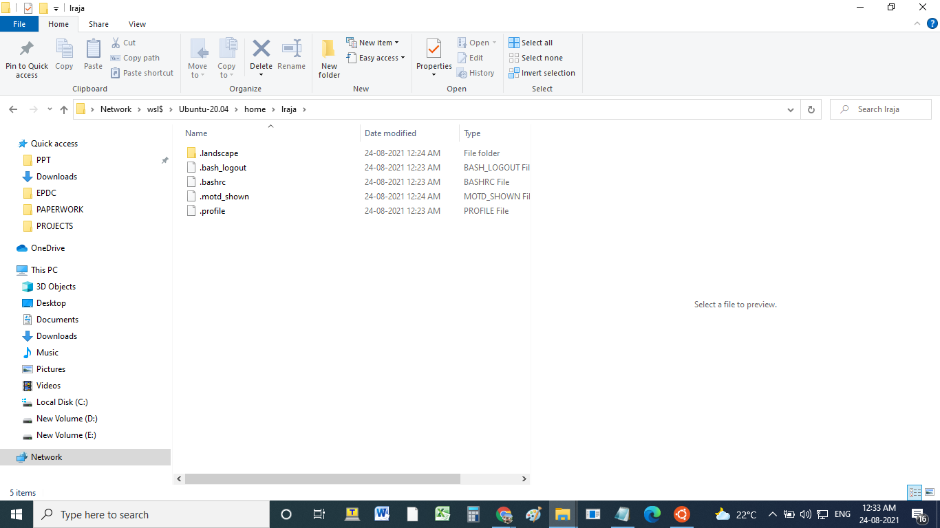

1. **Now unzip and keep the FreeRTOS file in this location**

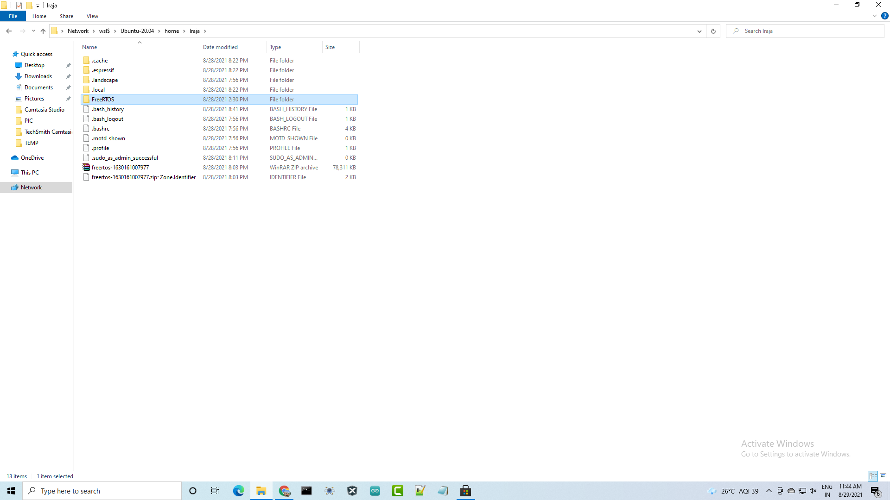

1. **Now we are going to give our thing a name that represents our physical device (ESP32) and give “Next”**

**Ex: MyExperimentwithESP32**

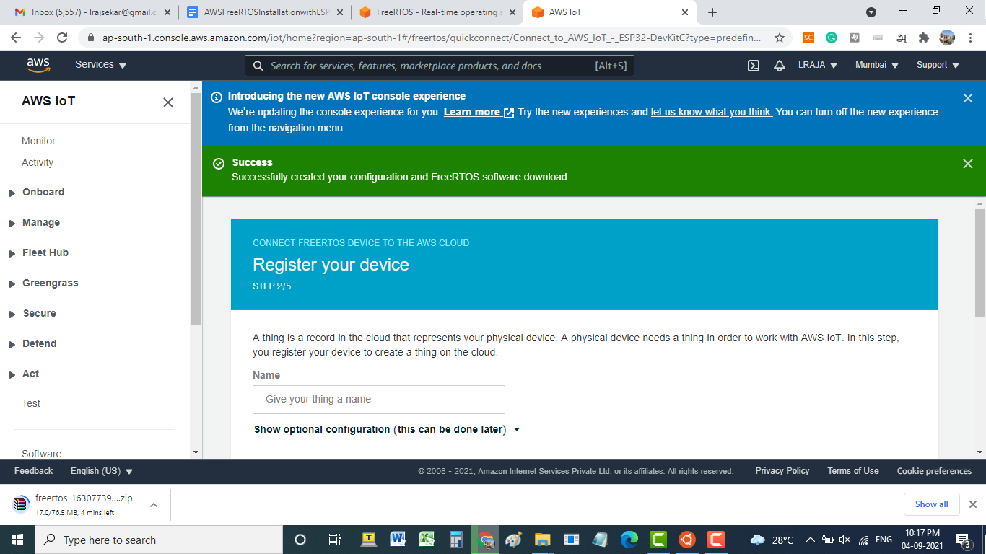

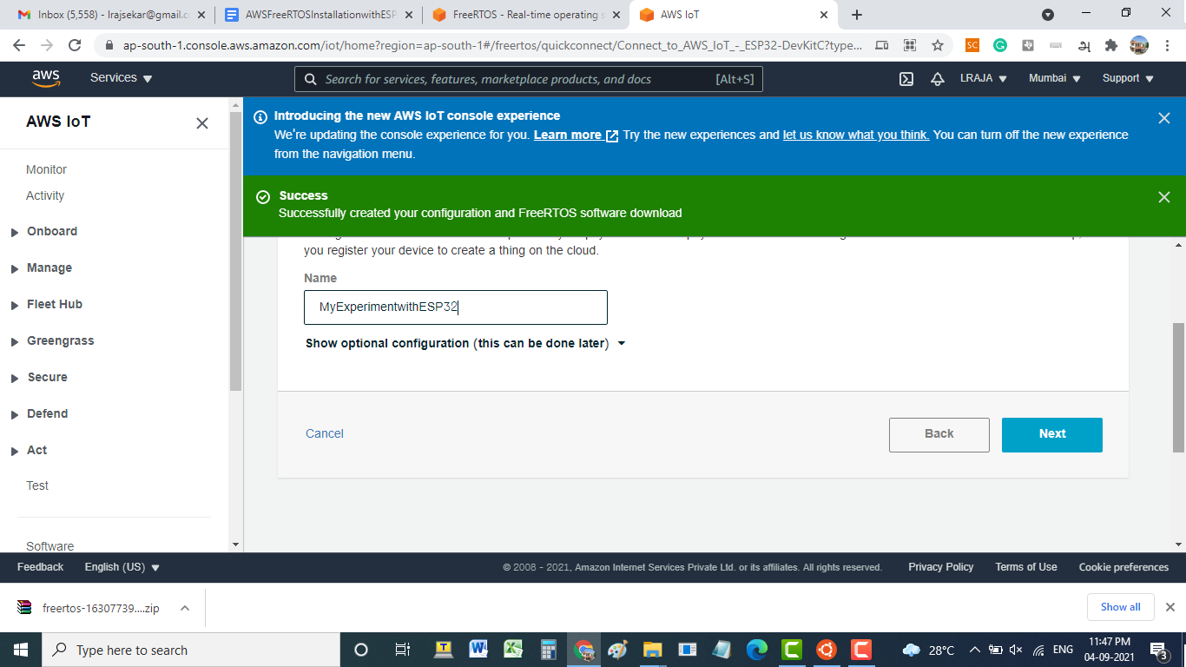

1. **Next, we click “Download and continue” to download the credentials which contain certificates and keys.**

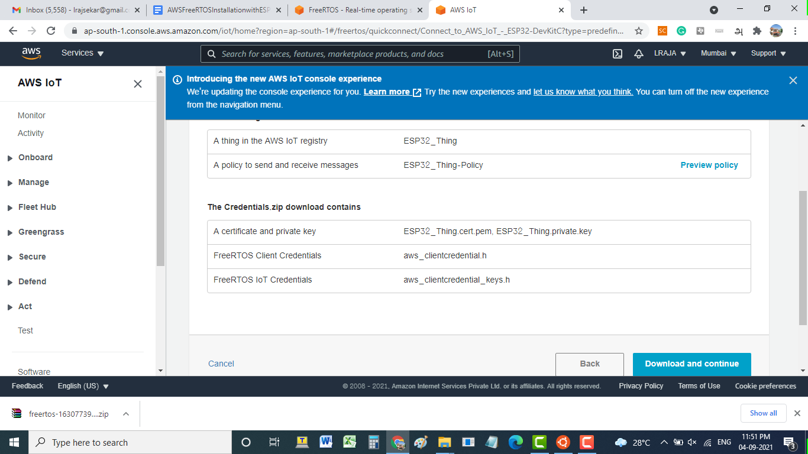

1. **Next click “Test” to test our device after we build and run the helloworld demo code on our device.**

**(**[**https://us-east-1.console.aws.amazon.com/iot/home?region=us-east-1#/freertos/quickconnect/Connect_to_AWS_IoT_-_ESP32-DevKitC?type=predefined**](https://us-east-1.console.aws.amazon.com/iot/home?region=us-east-1#/freertos/quickconnect/Connect_to_AWS_IoT_-_ESP32-DevKitC?type=predefined)**)**

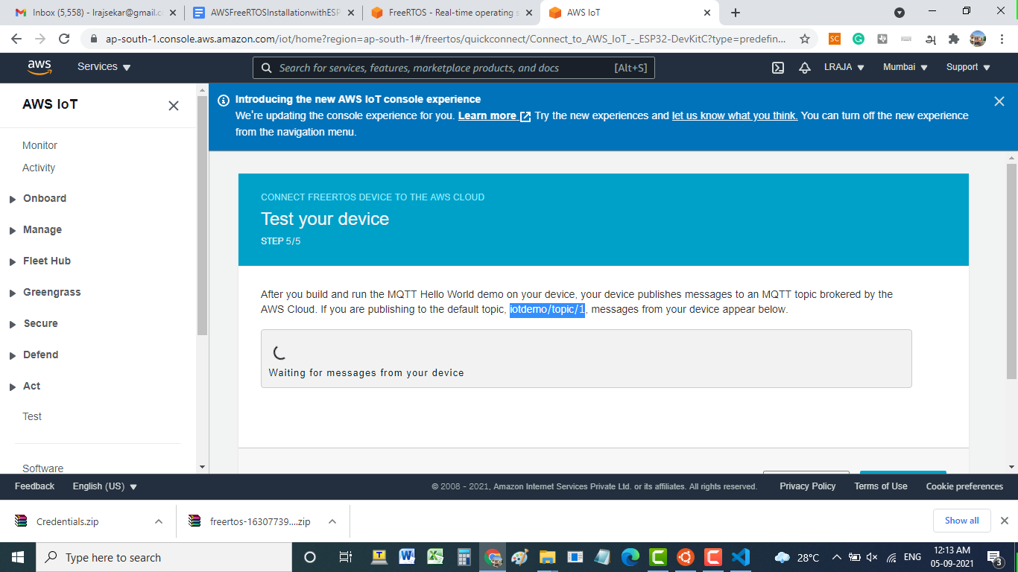

1. **Now unzip the credentials (credential.zip)**

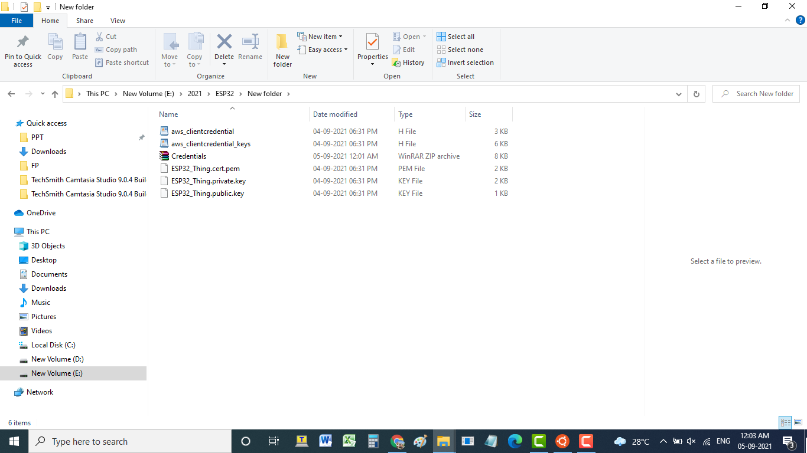

1. **In the Unzip credential folder, open the “aws_clientcredential.h” file. In the aws_clientcredential file, define clientcredentialWIFI_SSID as your network SSID and define clientcredentialWIFI_PASSWORD as your network password using the visual studio code editor.**

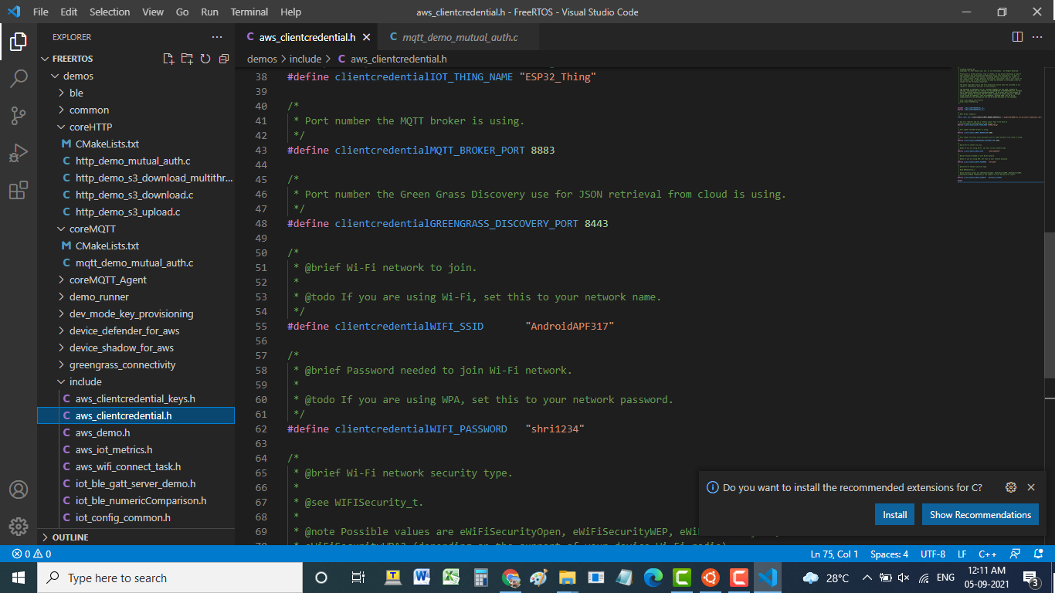

1. **Now copy the “aws_clientcredential.h and aws_clientcredential_keys.h “ files from the credentials folder and past them into \\wsl$\Ubuntu-20.04\home\lraja\FreeRTOS\demos\Include folder**

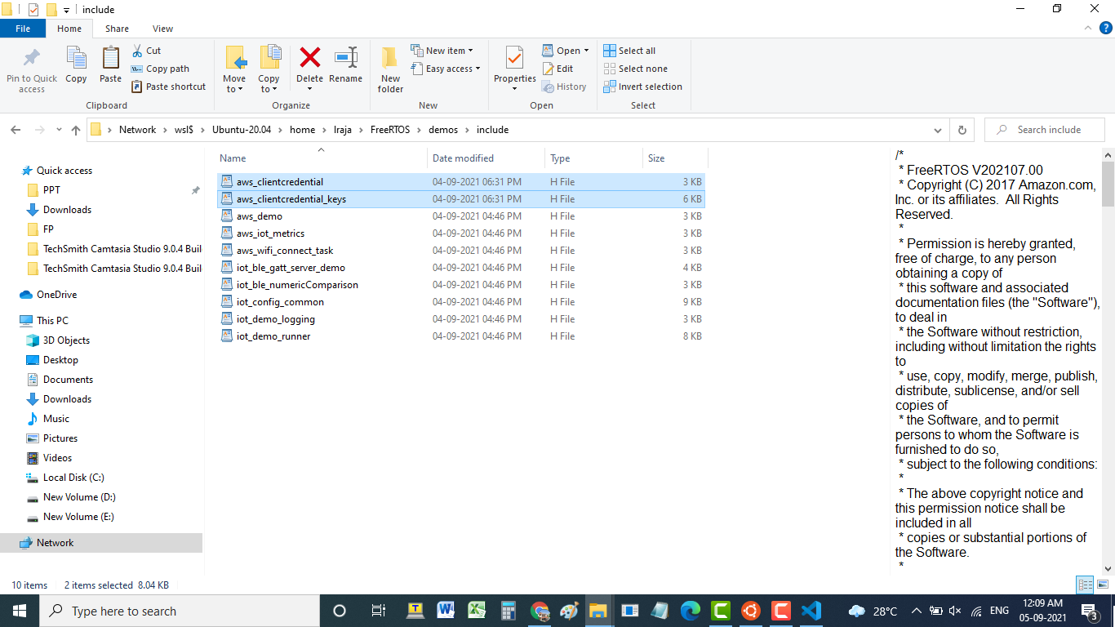

1. **Now define mqttexampleTOPIC as “iot demo/topic/1” in mqtt_demo_mutual_auth.c file**

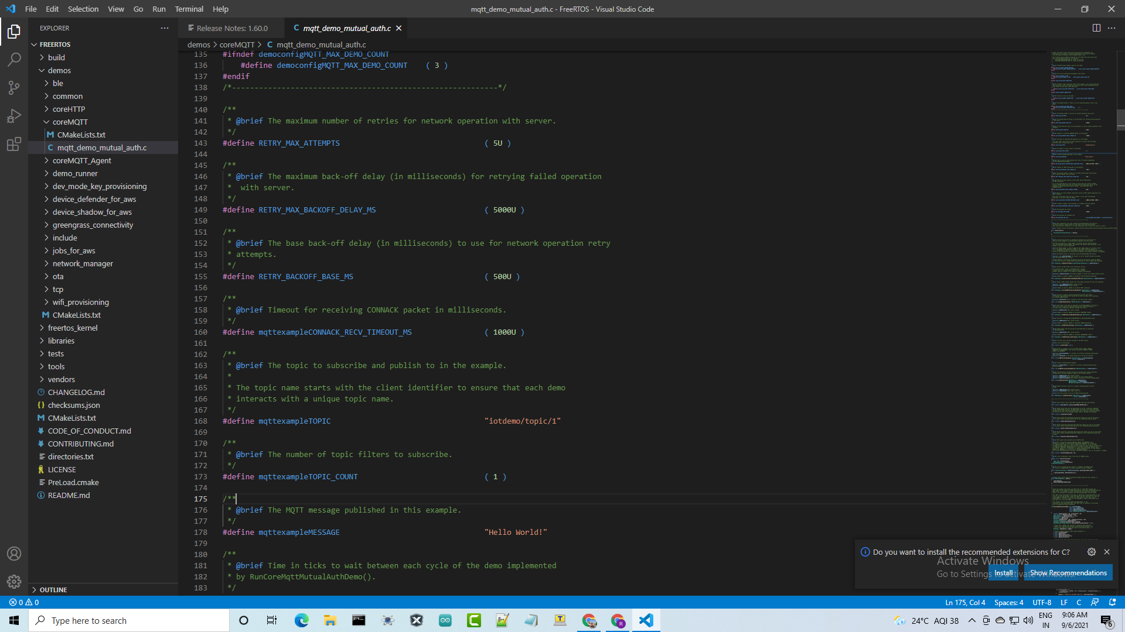

1. **Next, Open the ubuntu 20.4 WSL by clicking in the windows search**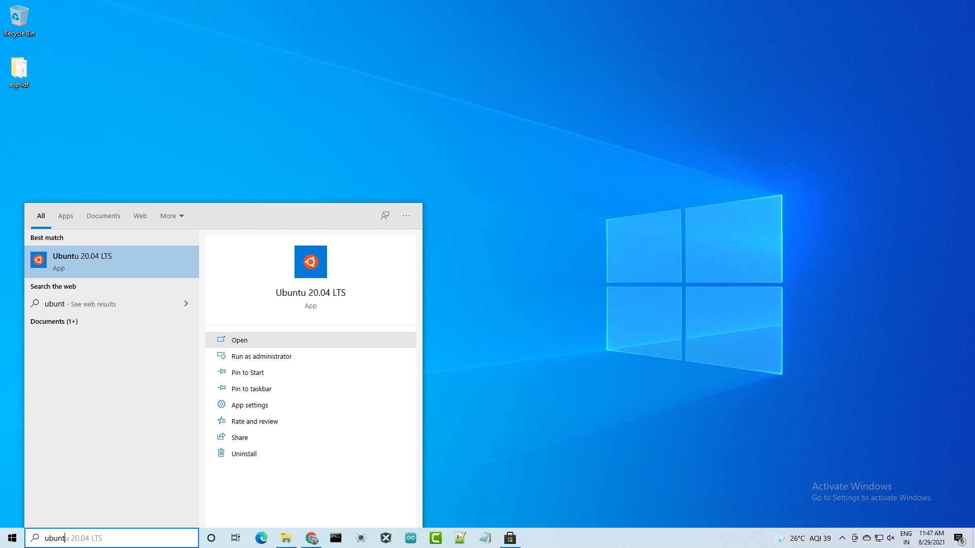

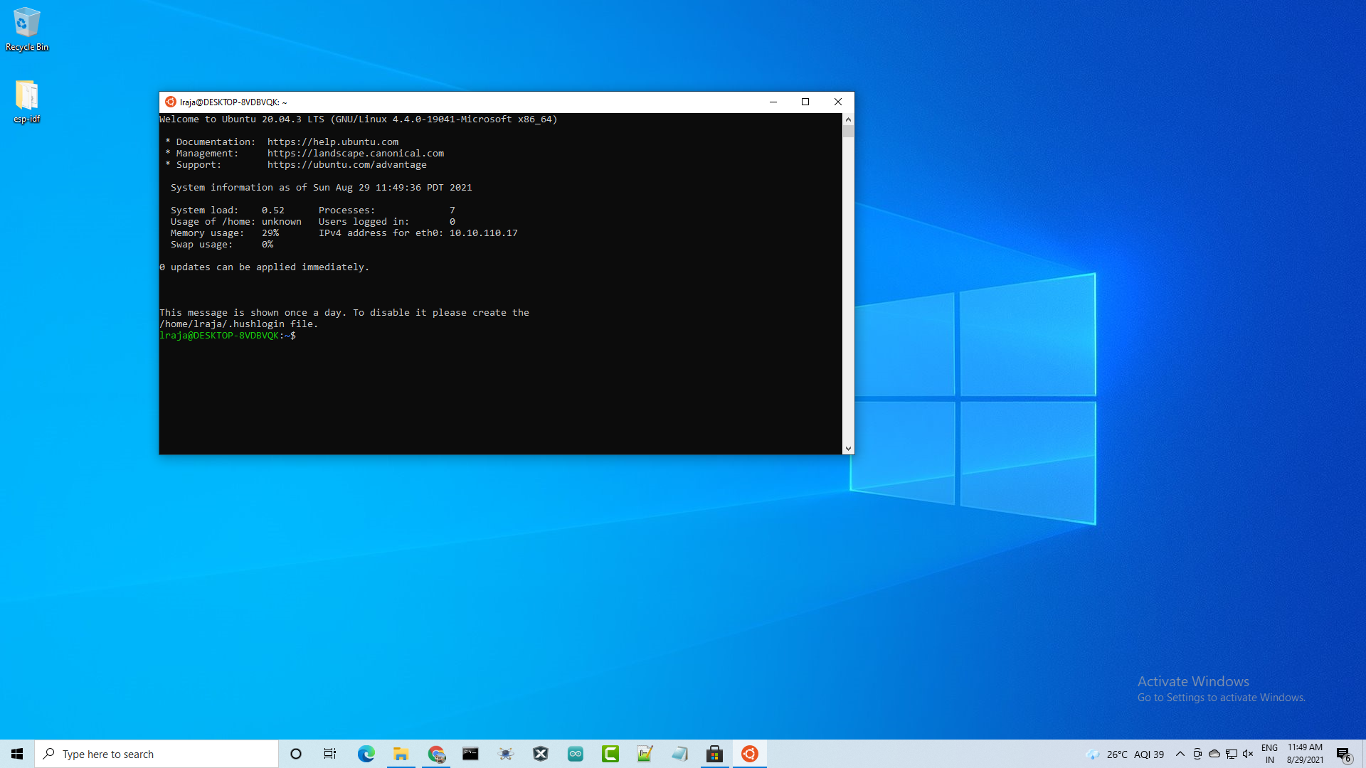

1. **This command will give the read, write and execute permissions to each file and folder in the FreeRTOS directory**

**>>sudo chmod -R 777 FreeRTOS/**

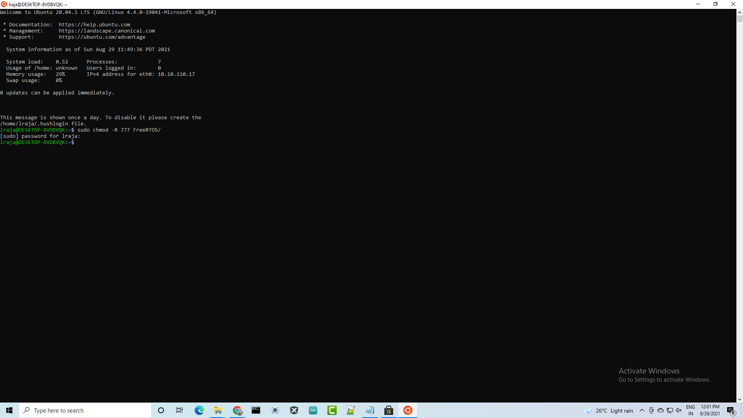

1. **Next, we are going to select the esp-idf folder from the FreeRTOS folder using the ‘cd’ command**

**>> cd FreeRTOS/vendors/espressif/esp-idf/**

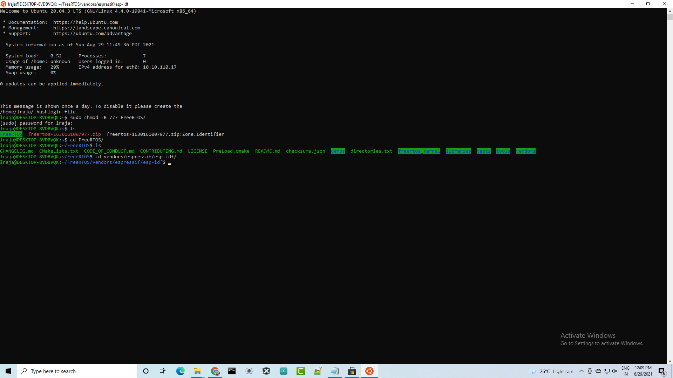

1. **Now set Python3 as default Python version using the following command,**

**>>sudo ln -s /usr/bin/python3 /usr/bin/python**

1. **Now we will update and upgrade the sources installed in the system by using the following command,**

**>>sudo apt update && sudo apt upgrade**

1. **Next, we need to install the following packages to compile using the ESP-IDF tool**

**>>sudo apt install git wget flex bison gperf python3 python3-pip python3-setuptools python3-serial python3-click python3-cryptography python3-future python3-pyparsing python3-pyelftools cmake ninja-build ccache libffi-dev libssl-dev**

**>>sudo apt install python3-pip**

1. **This shell script will install the ESP-IDF tools to compile, link and debugging the programs**

**>> ./install.sh**

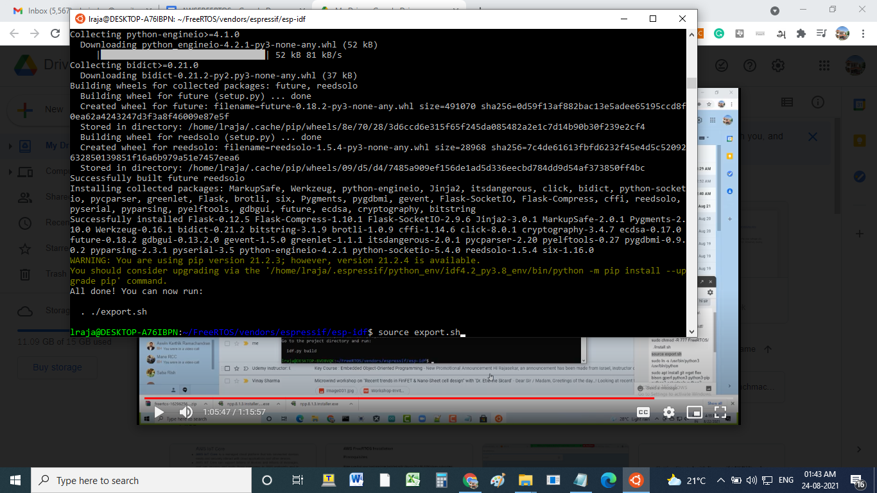

1. **Now we are going to export the environment variable of each tool and the current session of the terminal can find out the path of tools required for compilation and linking using the following command,**

**>> source export.sh**

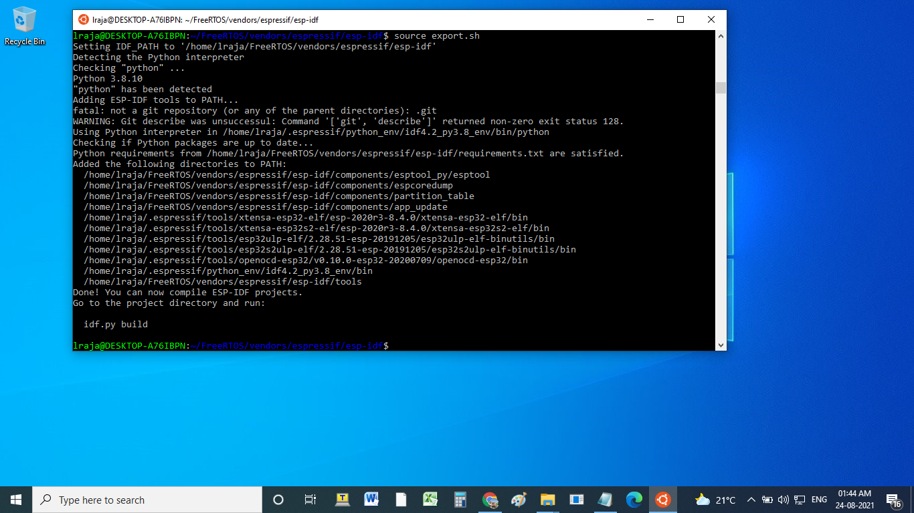

**25. Create certificate for signing the code :**

1- Download and install openssl : <https://github.com/openssl/openssl/releases/tag/OpenSSL_1_1_1j>

Or

>> sudo apt-get update -y

>> sudo apt-get install -y openssl

2- Add Openssl to the environment variable path

3- Create a directory and name it "Code_Certificate"

4- In your directory open command line prompt

5- Create a file named cert_config.txt. Add the following contest, Replace test_signer@amazon.com with your email address:

[ req ]

prompt = no

distinguished_name = my_dn

[ my_dn ]

commonName = test_signer@amazon.com

[ my_exts ]

keyUsage = digitalSignature

extendedKeyUsage = codeSigning

6- Create an ECDSA code-signing private key using the command:

openssl genpkey -algorithm EC -pkeyopt ec_paramgen_curve:P-256 -pkeyopt ec_param_enc:named_curve -outform PEM -out ecdsasigner.key

7- Create an ECDSA code-signing certificate:

openssl req -new -x509 -config cert_config.txt -extensions my_exts -nodes -days 365 -key ecdsasigner.key -out ecdsasigner.crt

**==================================================================**

**26.Open the code signer certificate(ecdsasigner.crt) file and copy the certificate content then paste it into the ota_demo_config.h file.**

**(FreeRTOS->vendors/espressif->boards->esp32->aws_demos->config_files->ota_demo_config)**

**\*following figure illustrates format for include the certificate**

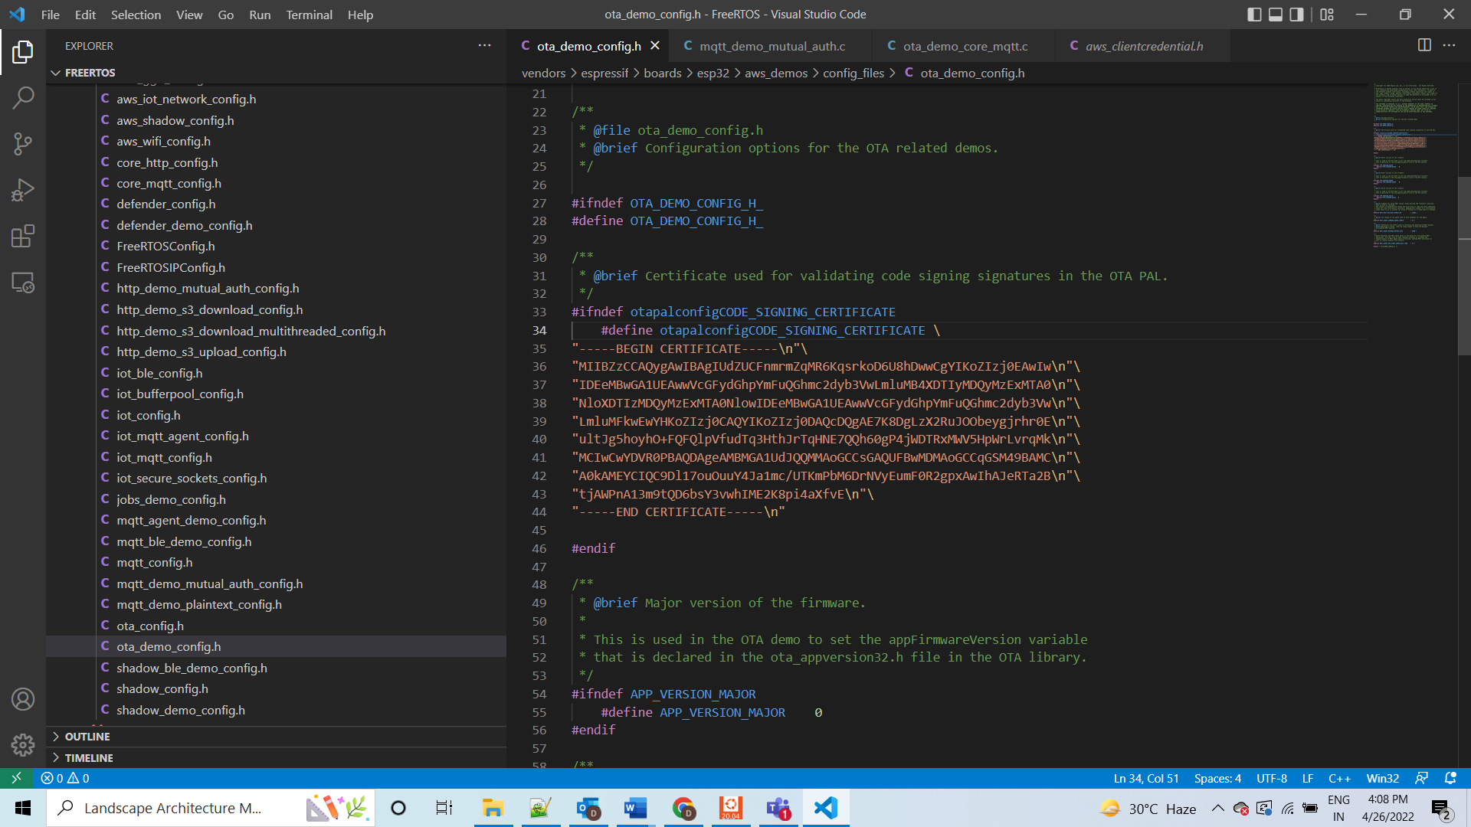

1. **Next, we are going to select the FreeRTOS folder using the ‘cd’ command for generating the configuration files**

**>>cd FreeRTOS**

**>>sudo chmod -R 777 .espressif/**

1. **Next, we are generating the configuration and build files via cmake build system in the FreeRtos/build directory by using the following command**

**cmake -DVENDOR=espressif -DBOARD=esp32_wrover_kit -DCOMPILER=xtensa-esp32 -GNinja -S . -B build**

**or**

**cmake -DVENDOR=espressif -DBOARD=esp32_wrover_kit -DCOMPILER=xtensa-esp32 -DCMAKE_TOOLCHAIN_FILE=tools/cmake/toolchains/xtensa-esp32.cmake -DAFR_TOOLCHAIN_PATH=/home/’username’/.espressif/tools/xtensa-esp32-elf/esp-2020r3-8.4.0/xtensa-esp32-elf/bin -S . -B build**

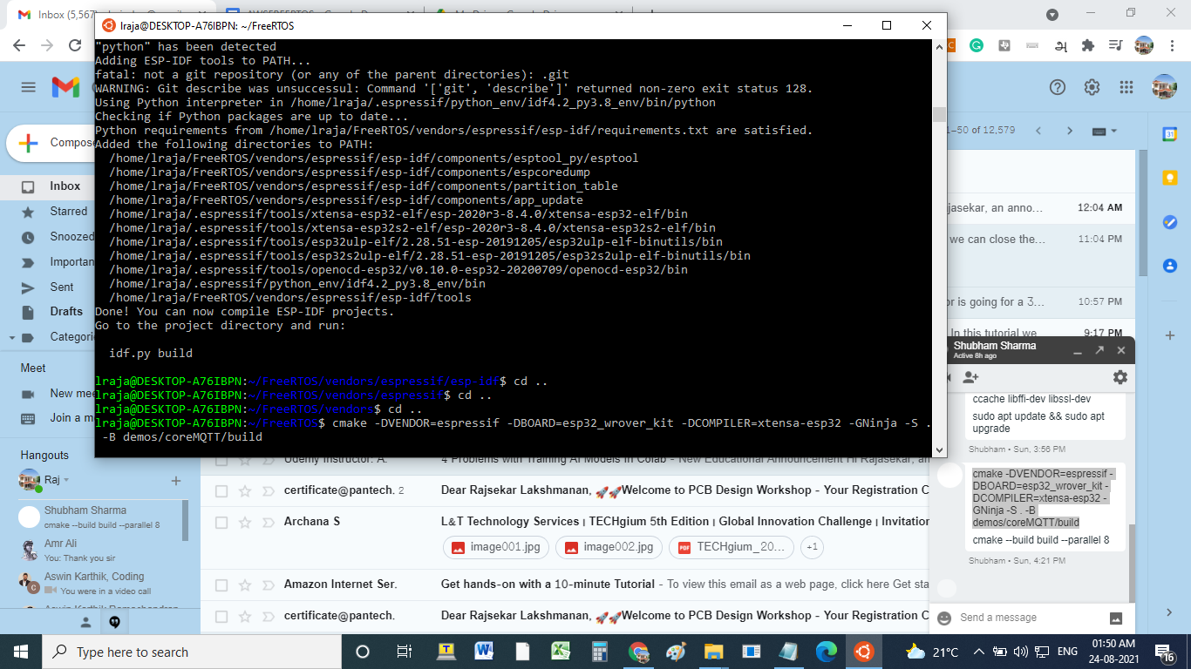

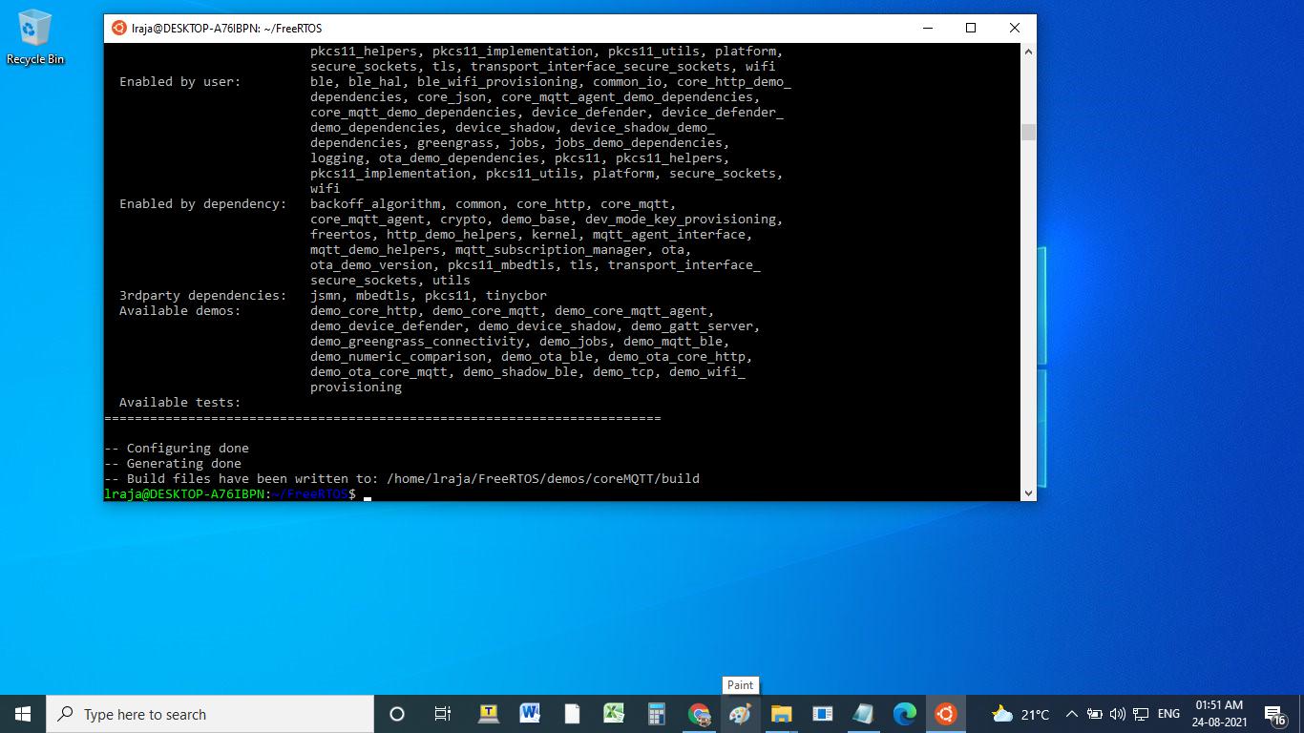

1. **Next, we are building the demo program via the build files generated in the build directory. Here parallel 8 flag indicate it will use 8 cores of the CPU to compile the program using the following command**

**>>cmake --build build --parallel 8**

**cmake --build build --target clean**

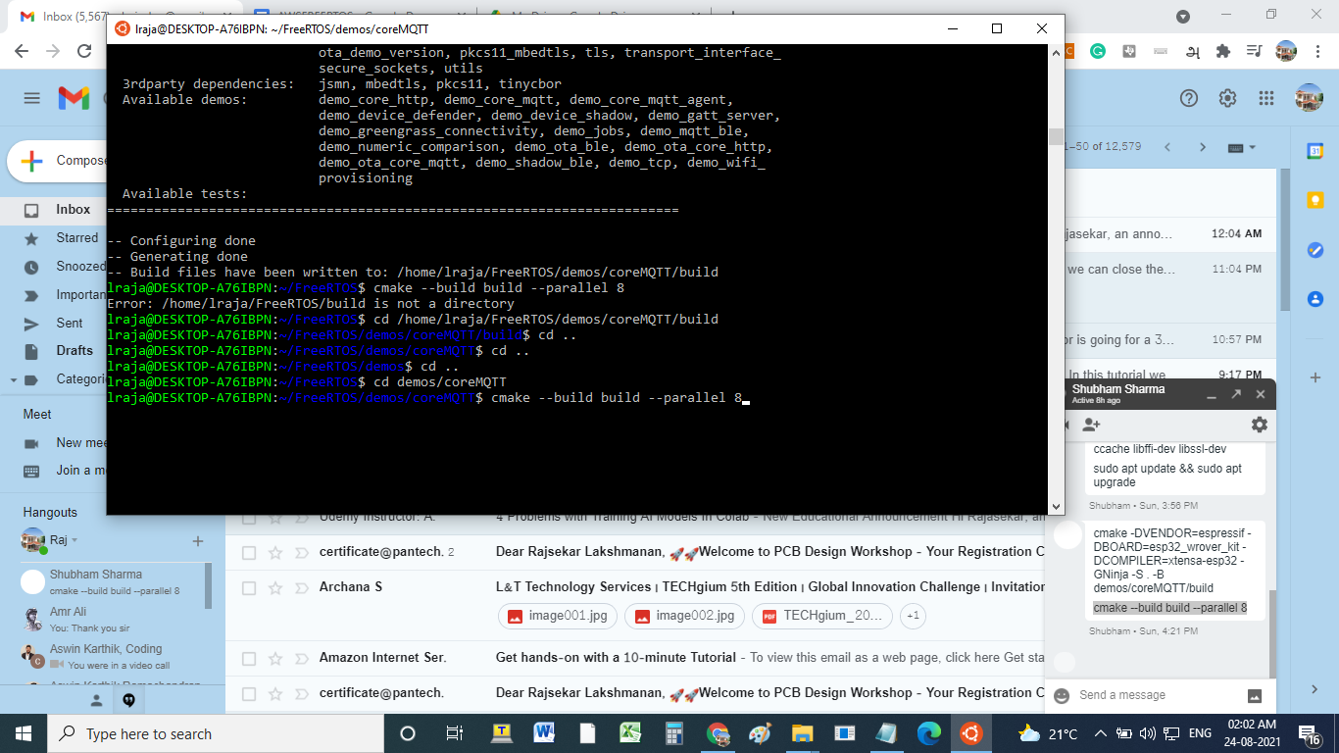

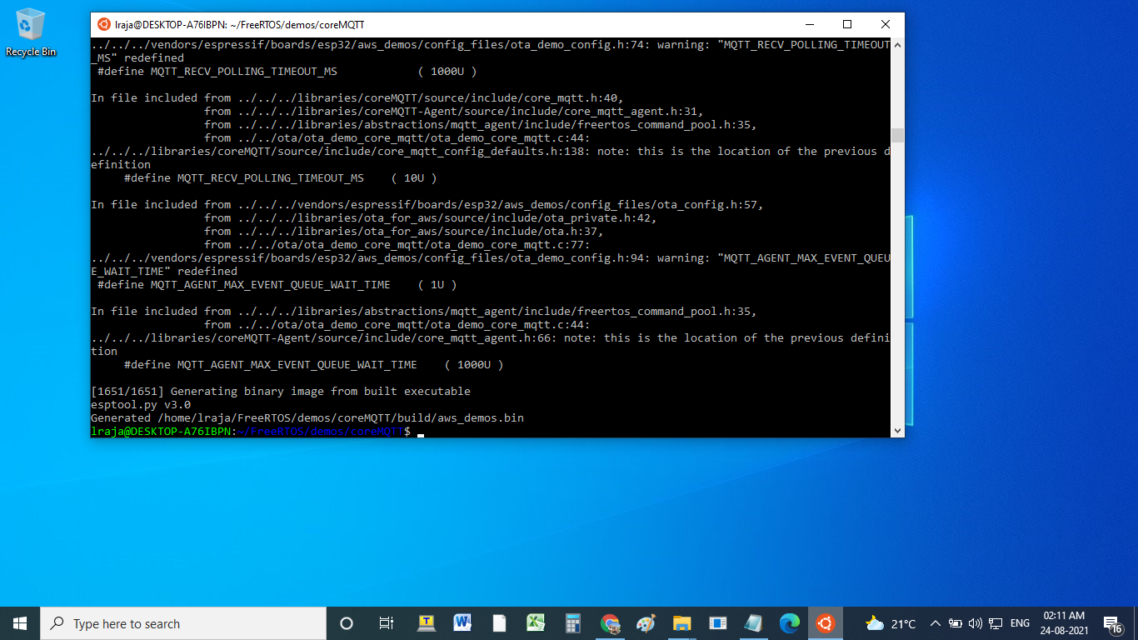

1. **Now connect your ESP32 board to the computer and check under what serial port the board is visible. After connecting the board, go to my computer and select the properties**

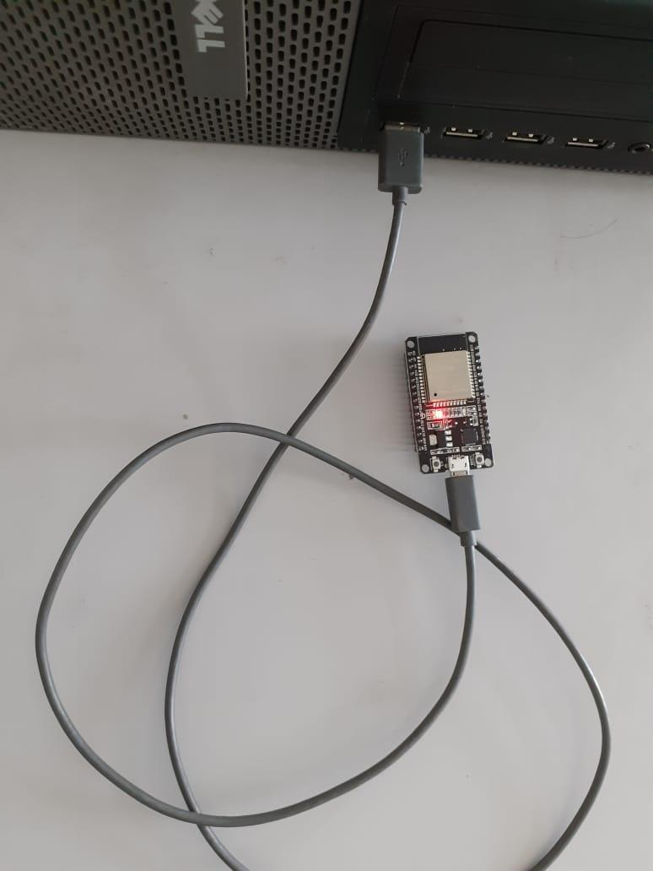

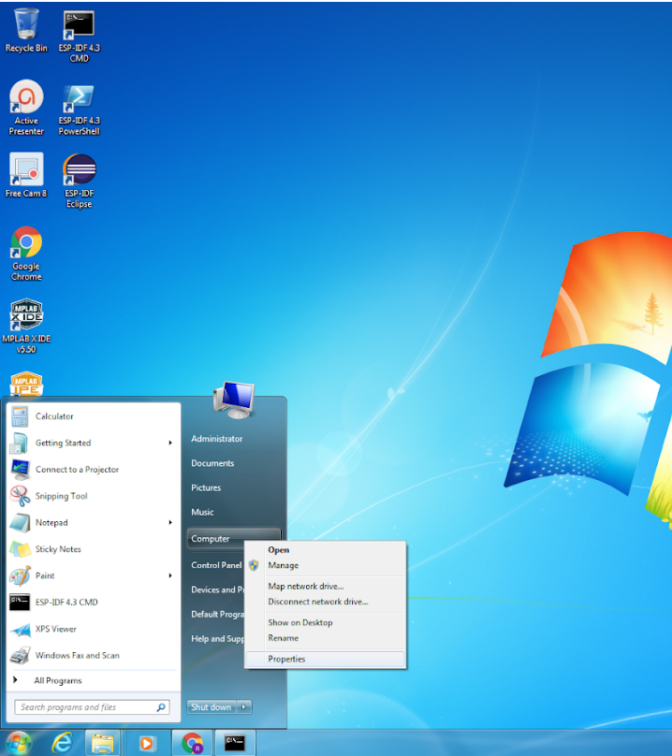

1. **Now click on the ‘device manager’ and expand the Ports ( COM/LPT)**

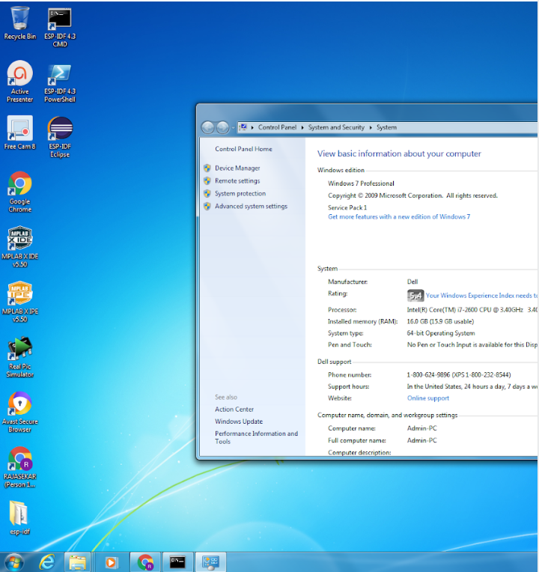

1. **Here you can find the newly connected devices' communication port number (Ex: COM3). Keep the port name handy as you will need it in the next steps.**
2. **Next, run the following command to build and flash binary file to your ESP32 board and also monitor the helloworld demo program output. Now your device publishes the helloworld message to an MQTT by AWS cloud.**

**>>idf.py -p /dev/ttyS5 flash -b 921600 monitor**

